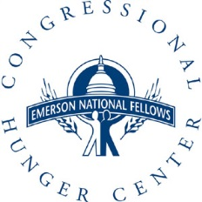

Bill Emerson National Hunger Fellows Program

2017 Field Site Project Proposal
Please answer the following questions about the project/s you propose for the Fellow(s). Successful project proposals typically include detailed project descriptions that outline how the project will meet the needs of communities, build the capacity of the organization and further your mission, allow Fellows to use and grow their professional skills, and have an impact on the food security, health, well-being, and quality of life of low-income Americans.
- Please describe the proposed project that you would like a Fellow to complete. (If your organization is requesting two Fellows, please provide two distinct answers.) Please discuss the following:

a. What are the goals?
b. What are the desired outcomes?
c. How does the work of the Fellow(s) connect to the needs/assets of your community?
d. What skills will be most beneficial for working on this project?
e. What resources, materials, and/or funding exist to support your proposed project?

- Please include a brief bio of the person who will have primary responsibility for supervising the Fellow. In addition to this, please describe the plans for providing supervision. Consider any support, oversight, resources, knowledge, and access— the Fellow will need to achieve the specific objectives in the work plan.

- Please describe your approach to mentoring, and how you plan to support the leadership development of the Fellow through your mentorship.

- Is your office accessible by public transportation? Most Fellows do not have use of a personal vehicle during the fellowship. Would use of a vehicle be required to successfully complete the proposed work plan? If so, please describe your plans for providing transport to the Fellow(s) should s/he not have access to a personal vehicle.

- Fellows will be securing housing over the summer, are there any resources or connections that you can offer to Fellows?

- Please provide any additional information that you would like the Emerson Program staff to consider when reviewing this application.

Please submit your project proposal using the application webform. If you have questions about the application process or would like to discuss your proposed project before submitting it, please feel free to contact Jon Wogman via email at jwogman@hungercenter.org or phone at 202-547-7022, x.29.

