**Lower Food Security in Upper Manhattan?**

**A survey of residents of Washington Heights and Inwood**



**Figure 1:** Washington Heights/Inwood Target Area

**Summary:**

City Harvest conducted a resident survey as part of a Community Food Assessment (CFA). The survey collected information about food security, eating habits, barriers to eating healthy in the Washington Heights and Inwood neighborhoods of Northern Manhattan, New York. City Harvest staff and community volunteers administered the surveys. The surveys targeted residents receiving emergency food, seniors and residents in general. The survey indicated high rates of food insecurity in Washington Heights and Inwood, especially among emergency food recipients. Further, the results reveal that all target populations in Washington Heights and Inwood face barriers while shopping for healthy food in their location. Affordability of healthy food was reported as the greatest barrier. Based on the data from the survey, neighborhood seniors and emergency food recipients are populations in need of better access to healthy foods at an affordable price. Emergency food recipients have experience food insecurity at a high level, and seniors have a high rate of encountering barriers when shopping for healthy foods. Responses from the survey indicated a demand and a desire for healthy food as the majority of the total population (and all target groups) eats sufficient fruits and vegetables in their diet. Although there is a clear desire among residents for healthy food, they face barriers to meet their need for healthier food options. City Harvest can address these barriers by providing residents with nutrition education programming, transportation to supermarkets, and collaborating with existing emergency food providers to offer healthy food.

**Introduction:**

City Harvest exists to end hunger in communities throughout New York City. It does this through food rescue and distribution, education, and other practical, innovative solutions. City Harvest helps feed 300,000 New Yorkers each week by rescuing high-quality surplus food and distributing it to a network of over 600 soup kitchens, food pantries, and other community food programs. In addition to providing immediate hunger relief, we help New Yorkers gain access to affordable, local, nutritious food, with the goal of creating sustained, long-term food security.

City Harvest’s Healthy Neighborhoods Initiative provides additional services to targeted neighborhoods in New York City. Programming includes community food assessments , retail partnerships for healthy food, nutrition education programming and courses, school interventions, agency capacity building, and marketing campaigns. City Harvest also operates a Mobile Market program, which distributes fresh produce, combined with nutrition education and cooking demonstrations. Mobile markets occur twice a month in Stapleton in Staten Island, Melrose in the Bronx, and Bed-Stuy in Brooklyn, Washington Heights/Inwood in Manhattan; City Harvest will add a fifth distribution site in Queens, in 2012.

The first step in City Harvest’s Washington Height-Inwood Healthy Neighborhood Initiative is to conduct a Community Food Assessment (CFA) in order to document the reality of available food and nutrition knowledge in the neighborhood. The objective of the CFA is to use community-based research to understand the barriers residents face to healthy eating, their beliefs and behaviors around food, and to begin to establish meaningful trust and partnerships within the community. The CFA enables City Harvest to work with residents to identify obstacles to eating well and create sustainable solutions to overcome them.

As part of the community food assessment City Harvest conducted resident surveys. The resident surveys were a 10 minute long survey administered by City Harvest staff and community volunteers to targeted residents of Washington Heights and Inwood.

City Harvest’s resident survey of Washington Heights and Inwood was designed to gain a better understanding of the food landscape in the two neighborhoods. Residents are experts of their own neighborhood and the food landscape of that neighborhood. Therefore resident surveys are one of the best and most effective methods for gaining this understanding. The main goals of the resident surveys was to understand residents shopping and eating habits, and bring to light barriers to eating healthy (both real and perceived) and how City Harvest can improve the food landscape in the neighborhood and access to healthier foods for residents.

**Methods:**

The Washington Heights and Inwood resident survey questions were informed from the preliminary environmental scan done of the neighborhood, past CFAs completed by City Harvest, as well as the USDA Community Food Security Tool Kit. The environmental scan consisted of gathering demographic information about the neighborhoods, reading health and food access studies that were related to the population of Washington Heights and Inwood, as well as researching and partnering with community based organizations and other community resources to learn more about the neighborhood and its residents. This scan of the neighborhoods was important, because it allowed City Harvest to better construct relevant questions for Washington Heights and Inwood.

Through both the environmental scan and brief interviews with community leaders, City Harvest established two main target areas within Washington Heights and Inwood, Southern Washington Heights and East Inwood.

Draft surveys were then tested several times in different parts of the neighborhood and among various populations. They were tested both in Southern Washington Heights and East Inwood, among seniors, ESL classes, and residents on the street. Based on the field test, surveys were adjusted, which allowed City Harvest to better construct a survey that was most relevant to the targeted neighborhood and population.



**Figure 2:** Southern Washington Heights



**Figure 3:** East Inwood



The areas of Southern Washington Heights and East Inwood have higher rates of poverty compared to the rest of the neighborhood as well as to New York City as a whole. After identifying these two main target areas, City Harvest established a target of 3 population groups based on the preliminarly findings and the enviornmental scan:

* Persons receiving emergency food
* Seniors (65 and older)
* Other Population (Non-senior, non-emergency food population)

After establishing the target populations and target areas, City Harvest began identifying potentail locations to conduct resident surveys. Though existing partnerships in the neighborhood and establishing new ones, the CFA team found senior centers, emergency food providors, ESL classes, supermarkets, community based organizations, and health clinics. The locations partnered with City Harvest to adminster surveys or allowed City Harvest and volunteers to administer the surveys.

The surveys were collected over a three week period at various locations in the target areas of Southern Washington Heights and East Inwood as seen below:

**Table 1:** Resident survey work plan



**Limitations:**

Due to multiple factors we were unable to complete the amount of surveys. These factors include:

* **Lack of volunteer support**: Local high school volunteers assisted City Harvest with administering the surveys. These volunteers were local high school seniors all from the Washington Heights neighborhood. The volunteers were helpful, however they were unreliable and at times failed to show up on days they were scheduled to adminster surveys. City Harvest orginally had scheduled 6 volunteers 3 days a week for 2 hours each day though a parntner organization in Washington Heights. The high school volunteers were scheduled to assist on 9 total days for 2 hours each day (a total of 108 hours). Do to school work and other unknown factors we only received 5 volunteers, and they were only able to assist on 6 total days for 34 total hours.
* **Lack of agency and partner support**:While admistering the surveys City Harvest also experienced agencies or partner organizations with whom we were conducting surveys with/ at their location; be unable to accomdate us on certain days or sometimes they were unable to accomdate us at all. These cases were not common however when they did arise. The CFA team had to work to identify new partners where surveys could be conducted.
* **Weather**: Weather also played a factor in completing surveys. There were several days where inclimate weather prevented City Harvest staff and volunteers from conducting surveys. On inclimate weather days as well as cold days residents were less likely to stop and complete a survey, especailly on the street, even with the offer of an incentive.
* **Self seclection**: Self selection was a problem with this resident survey, just as it is with many surveys. Those who had a desire to take the time to complete the resident survey appeared more likely to care about food and food access realted issues in Washington Heights and Inwood. This prevented City Harvest from admistering the maxium amount of surveys. To address this, City Harvest shortened their survey to approxmaitly 10 minutes, and provided incentives in the form of healthy snacks, raffles, and round trip MTA metro cards. These incentives were designed to encourage residents to complete the surveys and avoid the issue of self selection. Self selection was a problem with this resident survey, just as it is with many surveys.
* **Length/time of the survey**: The length of the survey prevented residents from completing it. The survey was longer than previous resident surveys conducted by City Harvest and at times it was challenge to keep residents engaged for the whole survey. To combat this City Harvest shortened their survey to approxmaitly 10 minutes, and provided incentives in the form of healthy snacks, raffles, and round trip MTA metro cards. These incentives were designed to encourage residents to complete the surveys.
* **Targeting proper target population**: Admistering the resident surveys to the specific focus populations presented a challenge for City Harvest. Finding locations to survey the target populations of seniors and emergency food recipitents proved difficult and ensuring that we got an equal ratio of all target populations was a challenge.
* **Lack of incentives**: Due to City Harvest’s budget for the CFA, the number of metro card incentives were limited to 200 where as we completed 288 surveys. The metro card incentives were the most effective incentives. Residents responded the best to them. The fact that NYC MTA no longer sells single ride metro cards (only round trip) in bulk caused the prices of the incentives to be greater.

In total 288 surveys were completed, however only 273 could be used because of incomplete answers, individuals surveyed not living in the target areas. The following shows the survey tally broken down by target populations and target areas:

**Table 2:** Number of surveys by target groups



**Graphs/Data:**

**Chart 1**

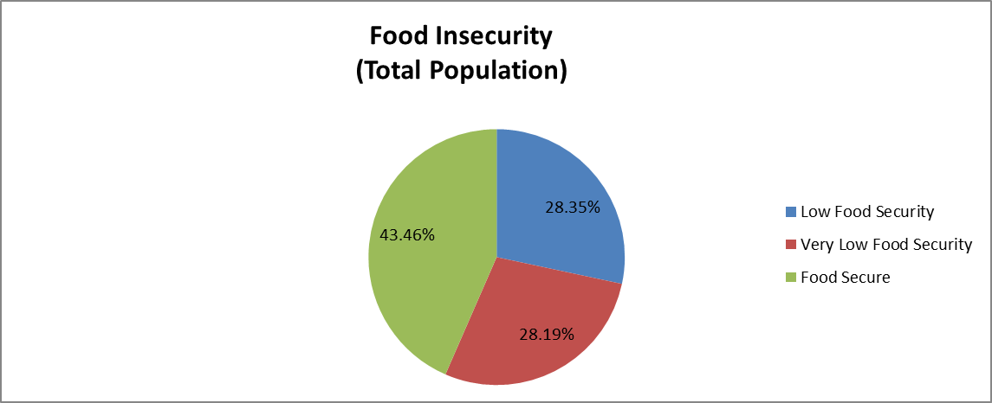

**Chart 1** shows the food security level of the entire population surveyed. Food insecurity was determined through asking the USDA food security questions in the resident survey. **Chart 1** shows that the majority (57%) of residents surveyed in Washington Heights and Inwood are food insecure. Of the food insecure residents 28% are experiencing **“**Low Food Security, and 28% are experiencing **“**Very Low Food Security.”

**Table 3**: Food Security Definitions



**Chart 2**

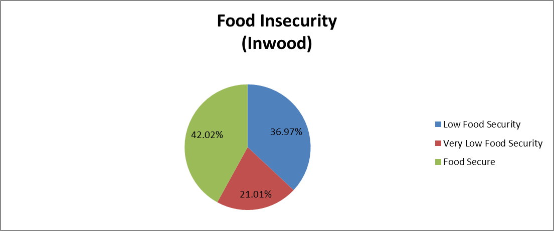

**Chart 2** shows the percentage of people surveyed in the Inwood target area and their food security level. The percentage of surveyed who are experiencing “Low Food Security” is 58% this is similar to that of the surveyed population as a whole (57% for the entire target area). The number of residents identified as experiencing “Very Low Food Security” is lower in Inwood than that of the entire target area (21% in Inwood vs. 28% in the entire target area).

**Chart 3**

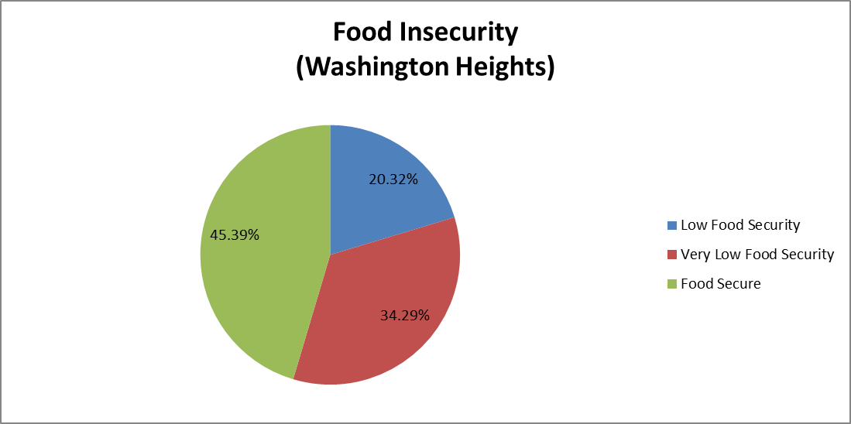

**Chart 3** shows the percentage and level of food secure and insecure survey respondents in the Washington Heights target area. The chart shows that 55% of the respondents are experiencing “Low Food Security,” this percentage is almost identical to that of the Inwood target area (58%) and of the target area as a whole (57%). The percentage of individuals experiencing “Very Low Food Security” is 34% in the Washington Heights target area; this percentage is higher than that of Inwood (21%) as well as that of the target area as a whole (28%).

**Chart 4**

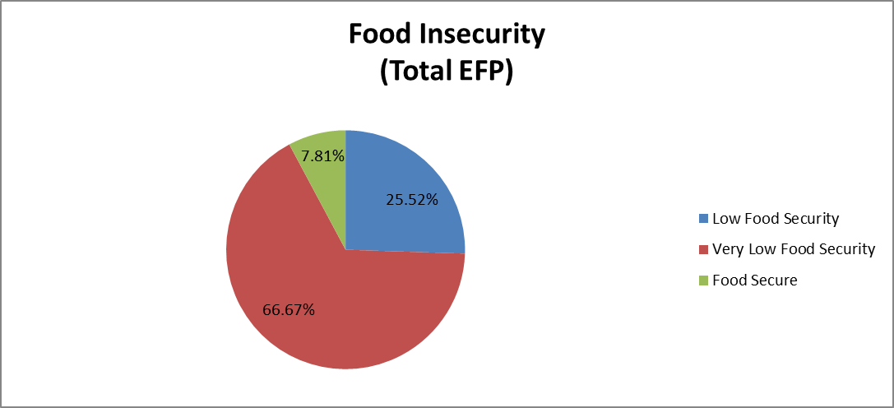

**Charts 4, 5, and 6** show residents surveyed receiving emergency food and their rates of food insecurity. **Chart 4** shows that an overwhelming percentage (92%) of residents surveyed at emergency food providers are experiencing “Low Food Security” and 67% are experiencing “Very Low Food Security.” The results for the target areas of Washington Heights and Inwood are similar. As seen in **Chart 5** below 94% of those surveyed at emergency food providers in Inwood are experiencing “Low Food Security” and 92% of residents surveyed at Washington Heights (see **Chart 6**) emergency food providers are experiencing “Low Food Security.” However of those surveyed in Washington Heights, 67% were determined to be experiencing “Very Low Food Security” compared to 53% in Inwood.

**Chart 5**

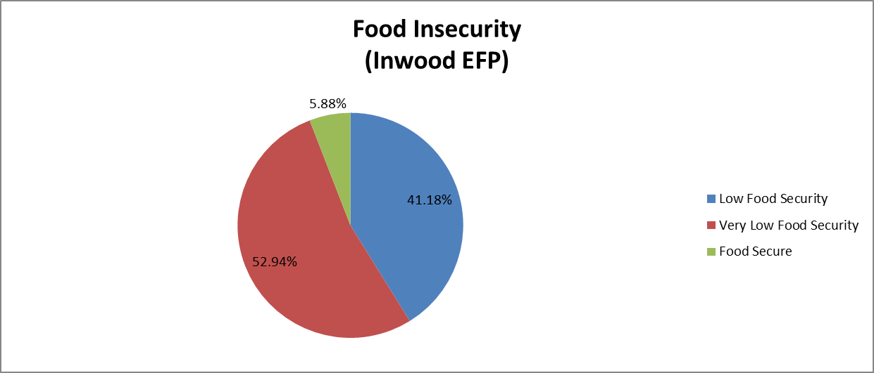

**Chart 6**

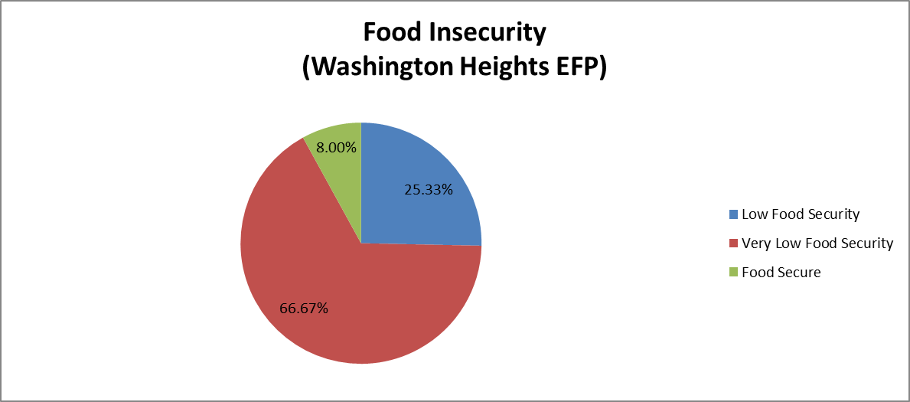

**Charts 7, 8, and 9** show the rates of food insecurity among seniors who were surveyed in our target areas. **Chart 7** shows that the majority of seniors in the target area are “Food Secure” (65%). Seniors surveyed in the Inwood target area (see **Chart 8**) had higher rates of food security than that of total seniors; 71% of Inwood seniors surveyed were “Food Secure.” The rates were lower in Washington Heights (see **Chart 9**), 61% of seniors surveyed in the Washington Heights target area were “Food Secure.”

**Chart 7**

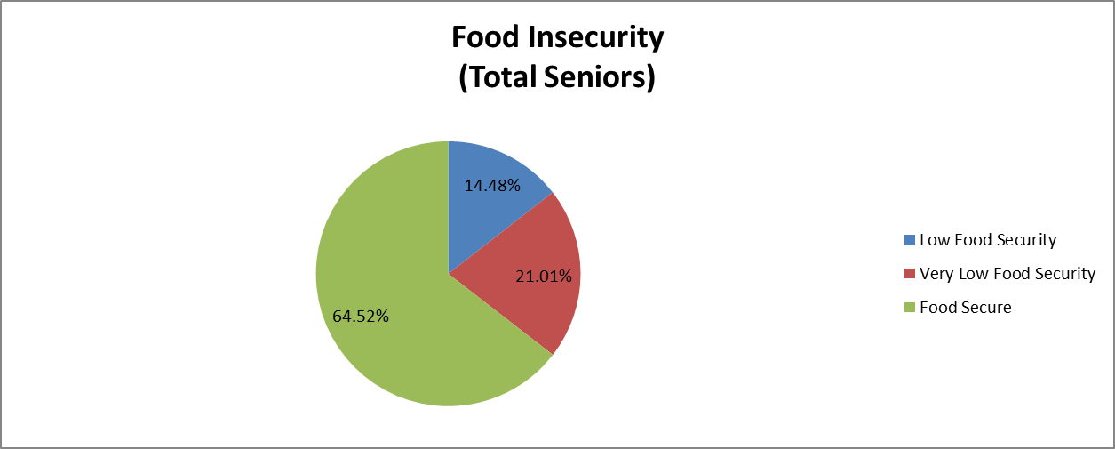

**Chart 8**

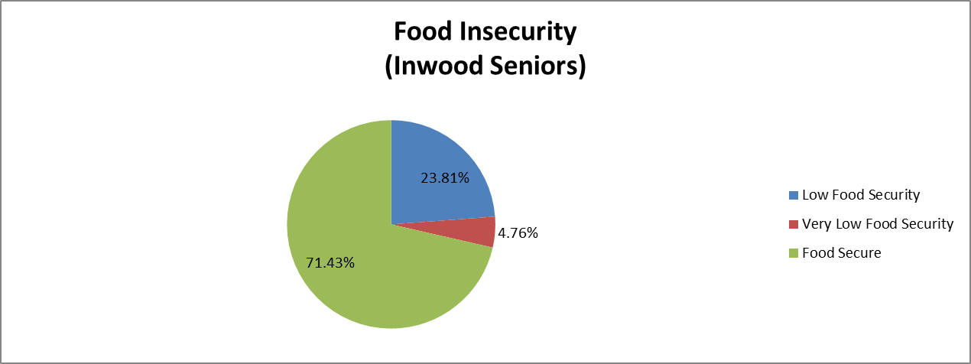

**Chart 9**

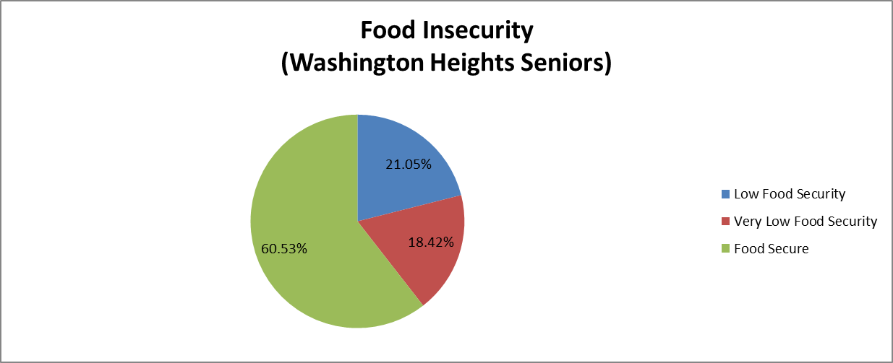

**Barriers to Healthy Eating:**

**Chart 10**

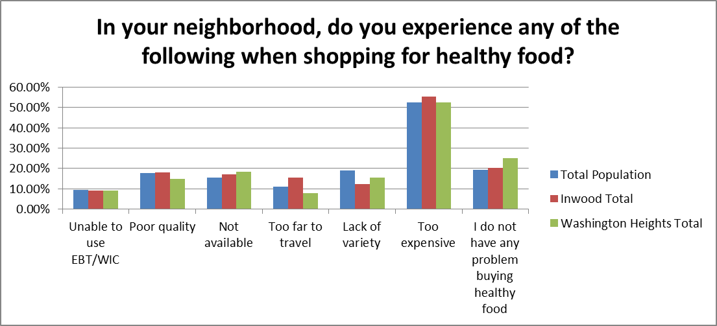

**Chart 10** above shows the barriers that respondents face in Washington Heights and Inwood. The results are similar between the total population surveyed and those surveyed in Inwood and in Washington Heights. The barrier that is encountered the most by those surveyed was healthy food being “Too expensive” with 52% of the total population saying they experienced high prices when shopping for healthy food. The target areas of Washington Heights and Inwood had a similar response rate; with 55% of survey respondents in Inwood saying that they experienced healthy foods being “Too expensive” and 52% of those surveyed in Washington Heights.

**Food Insecurity:**

Survey respondents receiving emergency food were far more likely to be food insecure than any other part of the population. The percentage of people determined to be experiencing “low food security” or “very low food security” who is receiving emergency food was 92% (94% in Inwood, and 92% in Washington Heights). This is higher than the percentage of the average population (57%) and that of the population surveyed who are not receiving emergency food (45%).

Of the total residents surveyed 57% are identified as experiencing “Low Food Security” or “Very Low Food Security.” There is very little difference in food security rates between our two main target geographic areas. The percentages are consistent in both the Inwood target area (58%) and the Washington Heights target area (55%).

The percentage of food insecure respondents differs across the population targets that City Harvest identified. Of the total seniors surveyed 35% have been identified as experiencing “low food security” or “very low food security.” The 35% is smaller than that of the average population (57%), and that of all the non-seniors surveyed (63%).

Of the other population surveyed 45% are experiencing “low food security” or “very low food security.”

Inwood seniors and Washington Heights seniors also differ on levels of food security. Of the Inwood seniors surveyed 29% were identified as experiencing **“**low food security” or “very low food security,” where in Washington Heights 39% of all seniors surveyed were identified as the same.



**Eating Habits:**

The majority of the population surveyed eats at least 2 cups of fruit at least 3 days a week, and at least 2.5 cups of vegetables 3 days a week (77%, 72% respectively of those surveyed). Those percentages are similar for the geographic targets of Washington Heights and Inwood, with 74% of people surveyed in Inwood eating 2 cups of fruits at least 3 days a week (68% eating 2.5 cups of vegetables), and in Washington Heights 78% (74% eating 2.5 cups of vegetables) doing the same.

The percentages of people in the target population of emergency food recipients eating fruits and vegetables is similar with the average population surveyed. 77% of emergency food recipients are eating at least 2 cups of fruits at least 3 days a week, and 75% of EFP recipients eat at least 2.5 cups of vegetables at least 3 days a week.

The other population surveyed of non-seniors and non-emergency food recipients had similar results for the fruit consumption with 72% eating at least 2 cups at least 3 days a week. Vegetable consumption however was lower than the other target groups (seniors, and emergency food recipients) as well as than the average population with 61% eating at least 2.5 cups of vegetables at least 3 days a week.

Seniors however appear to be eating fruits and vegetables at a higher rate than the average population. 87% of seniors eating a sufficient amount of fruits at least 3 days a week, and 88% are eating a sufficient amount of vegetables 3 days a week.

Within the target areas of Washington Heights and Inwood the target populations differ on their eating habits. Of Inwood seniors 84% eat sufficient fruits at least 3 days a week and 88% eat sufficient vegetables at least 3 days a week. This compares to 78% for fruits and 79% for vegetables for seniors in Washington Heights. This again compares to 77% for fruits and 73% for vegetables for the average surveyed population.



**What would make it easier for you to add more fruits and vegetables into your diet?**

The response “Ability to shop for and cook meals with fresh fruits and vegetables” had a high response rate for the entire population surveyed with 35% identifying this as something that would make it easier for respondents to add fresh fruits and vegetables into their diets. These rates are fairly consistent across the different target populations. At 13% Inwood seniors (21% of total seniors) has the lowest rate of feeling that this would make it easier to add fresh fruits and vegetables to their diet.

Of the total resident’s surveyed 33% feel that an “improved knowledge about the nutritional benefits of fresh fruits and vegetables” would make it easier for them to add more fruits and vegetables into their diets. 41% of emergency food recipients feel that “improved knowledge about the nutritional benefits of fresh fruits and vegetables” would help them add more fruits and vegetables to their diets, this was the highest rate of response.

A little over one quarter of the total population surveyed (26%) feels that “information about food pantries and soup kitchens providing healthy food in my neighborhood” would help them add more fruits and vegetables into their diets. Residents receiving emergency food feel that information about food pantries and soup kitchens that provide healthy food would help them at higher rates than that of the total population surveyed; with 38% of all emergency food recipients choosing this answer (38% for Washington Heights emergency food recipients, and 42% of Inwood emergency food recipients). Few seniors, particularly in Inwood, feel that this would help them add more fruits and vegetables to their diets; with only 8% answering that “information about food pantries and soup kitchens providing healthy food in my neighborhood” would help them (19% for seniors as a whole).

19% of the total surveyed population feel that they do not need to eat more fruits and vegetables or they eat enough fruits and vegetables. The rates of people who feel this is true for them differ across the different target populations, with a high of 63% of Inwood seniors feeling they have enough fruits and vegetables in their diet (48% for total seniors, and 36% for Washington Heights seniors). Non-seniors have lower rates of answering that they feel they eat enough fruits and vegetables than the total population; with 11% of all non-seniors surveyed answering this, and 17% of Inwood non-seniors, and 7% of Washington Heights non-seniors. Emergency food recipients are also less likely to feel they eat enough fruits and vegetables in their diet. 13% of all EFP recipients answered they get enough fruits and vegetables in their diet (26% of Inwood EFP recipients, and 8% of Washington Heights EFP recipients).



**Barriers to access when shopping for healthy foods:**

Of the barriers that were asked by City Harvest the number one answer was by far price. The “Too expensive” answer is a barrier for 52% of the population surveyed, the next highest barrier is “Lack of Variety” with 19% feeling that is a barrier, and 19% also answering that they “Do not have any problem buying healthy food.”

**Affordability** is the largest barrier identified by residents across every target location and target population, the percentages varied in each group but overall they were significantly higher than all the rest of the barriers identified. Price is identified by 63% of seniors and by 58% of emergency food recipients as a barrier to shopping healthy. The highest percentage (79%) of Inwood emergency food recipients feel that cost was a barrier, while 50% of Washington Heights emergency food recipients and Washington Heights non-seniors feel price is a barrier for them, this is the lowest percentage of any of the target groups.

**Unable to use EBT/WIC** is identified as a barrier to shopping healthy for some target groups, however the rates at which this barrier is identified varies across the target populations. Emergency food recipients say they are unable to use EBT/WIC and that is a barrier for them to shop for healthy foods, 17% of all emergency food recipients identified this as a barrier, with 21% of Inwood area emergency food recipients identifying it as a barrier. Only 3% of seniors identify this as being a barrier for them, with 0% of Inwood seniors identifying this as a barrier. This compares to 10% of the total population surveyed identifying “unable to use EBT/WIC” as a barrier.

**Poor quality** (of healthy foods in the neighborhood) is identified as a barrier to shopping healthy by 18% of the entire population surveyed. Seniors however identified “poor quality” as a barrier for shopping for healthy food at a rate of 23% which is the highest of all the target populations. Where 13% of people surveyed at emergency food providers identified poor quality as a barrier. 11% of non-seniors in Washington Heights identify “poor quality” as a barrier.

Having “**Too far to travel**” is a barrier by 11% of all people surveyed. This barrier is identified by 19% of all seniors and by 29% of Inwood seniors, these two populations have the highest rate of experiencing this barrier. 9% of non-seniors surveyed identify “too far to travel” as a barrier with only 6% of non-seniors from Washington Heights identifying this as a barrier, this population experiences the smallest rate of this barrier.

**No problems** (/Barriers) **buying healthy food** is identified by some survey respondents. Of the total population 19% say they “do not have any problems buying healthy food.” Washington Heights non-seniors say they do not have a problem buying healthy foods at the highest rate (28%). Of Inwood residents receiving emergency food only 5% say they “do not have any problems buying healthy food.”



**Conclusions:**

The resident survey conducted by City Harvest of the Washington Heights and Inwood shows the similarities and differences between the geographic target areas of Southern Washington Heights and East Inwood, as well as the similarities and differences between the population targets of seniors, emergency food recipients, and the other population (non-seniors, non-emergency food recipients).

The levels of food insecurity in the target area is experienced by over half of the population surveyed (57%). This is almost identical to that of the two physical target areas of Washington Heights and Inwood; with Washington Heights having 55% of people surveyed experiencing food insecurity and 58% of the residents surveyed in Inwood experiencing food insecurity. This is significant because Washington Heights and Inwood have a poverty rate of 25.8%, which indicates people in the target area of Washington Heights and Inwood who are above the poverty line but still experience food insecurity.

The target population experiencing the highest rates of food insecurity is residents receiving emergency food. The rates of emergency food recipients who have been identified as being food insecure is 92%; with 94% of emergency food recipients in Inwood experiencing food insecurity, and 92% in Washington Heights. This is compared to the overall food insecurity rate of 57% (55% for Washington Heights, and 58% for Inwood). This shows that people receiving emergency food are experiencing significantly higher rates of food insecurity compared to the total population surveyed (57%), as well as non-emergency food recipients surveyed (45%). The rates of food insecurity for Manhattan and New York City as a whole are 14% and 16% respectively.

The target population experiencing the lowest rates of food insecurity is seniors. Seniors are experiencing food insecurity *(“Low Food Security” + “Very Low Food Security”)* at a rate of 35%; with Inwood seniors having a rate of 29% and Washington Heights seniors having a rate of 39%. This is compared to the overall rate of 57%, and a rate of non-seniors of 63% (64% for Inwood non-seniors, 61% for Washington Heights non-seniors).

The food insecurity data shows that City Harvest’s target population for various initiatives should be people receiving emergency food. Also according to the data gathered non-seniors are in greater need of City Harvest programs and interventions than seniors. This may be due to the fact that 70% of the seniors surveyed were surveyed at senior centers. Seniors who attend senior centers are usually more likely to be active, social, and if they are attending a senior center they are eating at least one healthy balanced meal supplied by the senior center.

The survey data shows that affordability is the largest barrier when shopping for healthy food in the Washington Heights and Inwood neighborhoods. Through observation and preliminary focus group data, City Harvest concluded that when people say foods are too expensive they are specifically referring to healthy foods (fruits and vegetables primarily). Of the entire surveyed population 52% feel that healthy foods being “too expensive” is a barrier when shopping for healthy food in their neighborhood.

Price is the largest barrier to shopping for healthy food for all of the target population groups. Of the residents receiving emergency food 58% say that price is a barrier for them when shopping for healthy food. That amount is higher than that of the population as a whole and higher than the residents not receiving emergency food who 46% feel that price is a barrier. This shows that people receiving emergency food are more likely to be affected by the price or price increase of healthy foods. Those who are receiving emergency food are more likely to be at or below the poverty line than those not receiving emergency food. Some food pantries where City Harvest conducted surveys required income verification in order to receive food; while emergency food recipients as a whole, are more likely to name price as a barrier while shopping for healthy foods. Inwood emergency food recipients are far more likely to name price as a barrier, 79% of emergency food recipients surveyed named that as a barrier when shopping for healthy food. This is compared to 55% of the total surveyed population of Inwood, and 46% of the residents not receiving emergency food. This again shows the need for City Harvest to target their initiatives towards residents (specifically of Inwood) receiving emergency food.

While it was shown previously that seniors in both Washington Heights and Inwood have a lower rate of food insecurity compared to the average population, and non-senior population, and other population; seniors still experience a higher rate of food insecurity than Manhattan and New York City as a whole. Seniors also experience price as barrier at a higher rate than the total population. 63% of the total population of seniors experience price as a barrier when shopping for healthy food, this is over 10% higher than the total population (52%), and the non-senior population (51%). Seniors may not be experiencing as high rates of food insecurity, do to their ability to supplement their eating habits with seniors centers, farmers’ market nutrition program coupons (for seniors), and other means. Seniors however are still experiencing barriers while shopping for healthy foods. This shows that City Harvest should work with seniors and senior centers to better serve the senior population of Washington Heights and Inwood, as there is a clear need for help with access to healthy affordable foods.

The senior population surveyed encountered additional barriers when shopping for healthy foods (in addition to high prices) at higher rates than the rest of the population. Seniors were found to experience having “too far to travel” as a barrier when shopping for healthy food. Of the total population 11%, and 9% of non-seniors said they experienced this barrier, while 19% of seniors and 29% of Inwood seniors surveyed experience this same barrier while shopping for healthy food. Through observation, speaking with seniors while administering the survey, and preliminary focus group data, City Harvest can conclude that seniors are less likely to be able bodied and more likely to have a physical disability and therefore encounter greater problems traveling even within their neighborhood. This along with other barriers affecting seniors should be a priority for City Harvest to address.

Seniors are also more likely to eat 2 cups of fruits and 2.5 cups of vegetables than the rest of the population. Of the whole population surveyed 77% eat sufficient fruits at least 3 days a week and 72% eat sufficient vegetables at least 3 days a week. The rates are even higher for seniors in the target areas, with 82% of seniors eating at least 2 cups of fruit at least 3 days per week, and 87% eating at least 2.5 cups of vegetables 3 days per week. This data shows that persons in Washington Heights and Inwood are getting sufficient fruits and vegetables daily; however as seen in previous survey questions and data barriers to shopping for healthy foods, and food insecurity exists and is prevalent in the target areas, and amongst the target populations.

Seniors still encounter barriers at higher rates than the total population and the non-senior population. Some barriers identified are price, poor quality of healthy foods, too far to travel to get healthy foods. Since seniors are more likely to eat sufficient fruits and vegetables even though they experience barriers at high rates than the rest of the population they provide a good opportunity for City Harvest to work with the population. With seniors, City Harvest will have the opportunity to work with a targeted population that is in need of interventions and programming that would allow them easier access to healthy foods, and the desire to eat healthy foods already exists as seen in the rates of fruit and vegetable consumption. Through conversations while administering the surveys, and preliminary focus group data it is clear that seniors would like help with transportation to and from grocery stores (especially less-abled and disabled seniors), and a way to supplement their consumption for healthy fresh produce, such as health bucks or better access to farmers’ market nutrition program coupons (for seniors).

Emergency food recipients experience far higher rates of food insecurity than the rest of the population, and the other target groups. Of emergency food recipients surveyed 92% are identified as food insecure *(“Low Food Security” + “Very Low Food Security”)*; compared to 57% of the total population, 45% of non-emergency food recipients, and 35% of seniors. This data shows City Harvest that there is a great need for programming and interventions surrounding the population receiving emergency food in Washington Heights and Inwood; the data is showing that the emergency food being distributed in the target areas is not sufficiently meeting the needs of the community receiving it because even with the emergency food the recipients still have a high rate of food insecurity.

Emergency food recipients identified the largest barrier while shopping for healthy food as price; this is in line with both the targeted and total populations. Emergency food recipients however, experience price as a barrier at a higher rate (58%) than the total population (52%), as well as than the residents not receiving emergency food (46%). Inwood emergency food recipients have an even higher rate of experiencing this barrier with 79% of survey respondents identifying price as a barrier, with 55% of Inwood residents experiencing this barrier. This shows that while price is a barrier for all populations within the target areas of Washington Heights and Inwood, among emergency food recipients it is more prevalent. Emergency food recipients have a clear need for City Harvest programming even compared to the other target population within the neighborhood.

Residents receiving emergency food are less likely to feel they are getting enough fruits and vegetables. Of emergency food recipients, 13% feel that they are getting enough fruits and vegetables (only 8% of EFP recipients in Washington Heights); compared to 19% of the total population surveyed (16% in Washington Heights), and 22% of non-emergency food recipients. This shows that there is a need or at least a perceived need amongst residents receiving emergency food in the target areas, especially in the Washington Heights target area.

Emergency food recipients identified that “improved knowledge about the nutritional benefits of fresh fruits and vegetables” and “information about food pantries and soup kitchens providing healthy food in my neighborhood” as things that would make it easier for them to add more fruits and vegetables to their diets. A higher percentage of emergency food recipients identified these as ways to add more fruits and vegetables to their diets than the general population, and the residents not receiving emergency food. 41% of emergency food recipients identified “improved knowledge about the nutritional benefits of fresh fruits and vegetables” as a way to as a way to add more fruits and vegetables to their diet; compared to 33% of the total population and 31% of non-emergency food recipients. While 38% of emergency food recipients said that “information about food pantries and soup kitchens providing healthy food in my neighborhood” would help them add more fruits and vegetable into their diets; compared to 26% of the total population and 23% of the non-emergency food recipients. This shows that there is a need and a desire for improved knowledge about nutritional benefits of healthy foods that can be done through nutrition education. Residents showed a desire for an increase in healthy food and fresh produce.

Emergency food recipients are eating sufficient fruits and vegetables at an equal or higher rate than the total population as well as than non-emergency food recipients. 77% of emergency food recipients are eating at least 2 cups of fruits at least 3 times per week, and 75% are eating at least 2.5 cups of vegetables at least 3 days per week. This is the same for the entire population (77%) for fruits, and more than for vegetables (72%).

Washington Heights and Inwood have higher rates of food insecurity than that of Manhattan, New York City, and the whole country. While it has been shown through the results that there are target populations within Inwood and Washington Heights that have a high need for City Harvest programming and services (seniors, emergency food recipients) the entire population of Washington Heights and Inwood, specifically Southern Washington Heights and East Inwood is in need of programming and services to increase food security and decrease barriers to shopping for and eating healthy foods. This can be seen by the fact that the of total surveyed population of Washington Heights and Inwood over half are experiencing some barrier when shopping for healthy foods and of the other population surveyed (non-seniors, non-emergency food recipients) 50% are experiencing at least one barrier when shopping for healthy foods. Also the food insecurity rates for the total population surveyed and the other population are 57% and 36% respectively. These rates are much higher than the Manhattan, New York City, and national rates of 14%, 16.2%, and 14.5% respectively.

Overall the data shows that the target population of emergency food recipients is a population in need of City Harvest programming through their work with emergency food providers, and nutrition education classes. This population has the highest rates of food insecurity of any target population surveyed, showing that the need is there. Even with the high rates of food insecurity emergency food recipients eat sufficient servings of fruits and vegetables at higher rates than the total population; this shows that while there are barriers to eating healthy, there is a strong desire of the emergency food population to eat a healthy diet. Emergency food recipients identified “improved knowledge about the nutritional benefits of fresh fruits and vegetables” and “information about food pantries and soup kitchens providing healthy food in my neighborhood” as things that would make it easier for them to eat healthy. They identified these actions as a way to do this at a higher rate than the total population. This shows that City Harvest has an opportunity to work with emergency food recipients through nutrition education as well as through its network of emergency food providers providing and encouraging them to provide more produce.