Building the Base: Grassroots Organizing for the Immigrant Rights Campaign
A guide to successful organizing model used by Causa Justa::Just Cause
^{By: Jarymar Arana}

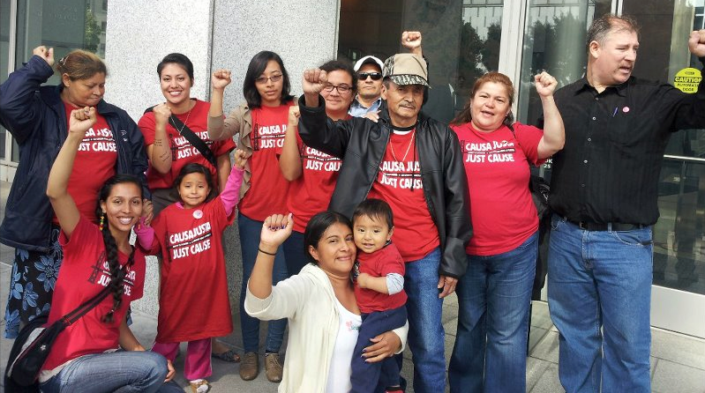
Photo credit: Causa Justa::Just Cause

The following is a brief overview of the grassroots-organizing model used by Causa Justa::Just Cause (CJJC) to defend and advance immigrant rights in the San Francisco and Alameda County Bay Area.

One unique method in building a base to build a movement is the makeup of leadership. Many community members that become leaders in the movement are working class, older Latino immigrants. They have gone through hardships and know first hand the impact of national deportation and separation of families. Causa Justa::Just Cause believes that the leaders in the movement to advance immigrant rights should be those most affected.

- The report highlights key victories won through the Immigrant Rights Campaign and current policy priorities and aims to show how CJJC is succeeding by using strategies to serve immediate needs and grow grassroots leadership including:

  - Service through Know Your Rights (KYR) Trainings and referral services
  - Member engagement and Outreach through door-knocking
  - Leadership development through “one on one” individual meetings and Immigrant Rights Campaign committee meetings

The guide can be used by organizing or advocacy organizations to orient themselves around what immigrant rights work can look like and how some tactics can be used to build a base and build a movement towards justice for immigrant communities.

Causa Justa::Just Cause and the Immigrant Rights Campaign History
- Tactics on building the base
  - Path of a Member

Know Your Rights

Door-knocking outreach

One-on-ones

Appendix

A: Know Your Rights Materials

B: One on One Materials

C: Coalitions

“On January 1, 2010, St. Peter’s Housing Committee and Just Cause Oakland merged to form Causa Justa :: Just Cause (CJJC). Prior to the merger, St. Peter’s Housing Committee had been working for more than 25 years defending tenants’ and immigrant rights and fighting gentrification in San Francisco’s Mission District. Just Cause Oakland emerged from the Prop EE campaign ten years ago and began its work to build people’s power and defend housing rights.” (www.cjjc.org)

For decades, the struggle for the protection and advancement of immigrant rights has been active in the United States. In this most recent decade, the culmination of grassroots organizing and community mobilization became very evident in the massive demonstrations that occurred in California and in other parts of the country on May 1st 2006. During this time, Cinthya Munoz Ramos, lead immigrant rights organizer for Causa Justa::Just Cause, was very active in mobilizing community members through student walkouts, community forums and marches.

Cinthya came into the work of Immigrant Rights as the first full time paid staff member to work on the Immigrant Rights Campaign when she joined the St. Peter’s Housing Committee in San Francisco in 2007. Before the merger in 2010, the St. Peter’s Housing Committee in San Francisco always had a focus and priority on immigrant rights, since it’s beginning in 1986.

As an organization, St. Peter’s Housing Committee was active in the immigrant rights movement because it was so familiar with the struggles of the immigrant community, as was seen and heard through many of the tenant’s stories when they came to see a housing counselor. A majority of the clients were Latino immigrants and the correlation between unfair treatment and harassment by landlords in the immigrant community was obvious.

After the merger of Just Cause Oakland and the St. Peter’s Housing Committee to form Causa Justa:: Just Cause, the organization remained committed to immigrant rights and Cinthya Munoz Ramos continued to be the lead organizer for the Immigrant Rights Campaign.

In order to successfully build a movement, CJJC works to build a solid base of community member leaders. Part of the priorities for the IRC is to establish and grow the Immigrant Rights Campaign member committee, integrate member feedback, participation and leadership around coalition work and to engage the current members of the IRC committee in the base building and recruitment work. In order to achieve leadership development, CJJC follows a model called Path of a Member:

Path of a member
  - First Contact is someone who first learns about CJJC through:
    - Door-knocking
    - Know Your Rights training
  - Member is a first contact who makes a decision to become involved with CJJC.
    - Pay a membership fee ($2 monthly)

Active Member is a member who becomes more involved by:
    - Attending meetings (monthly member meetings or Immigrant Rights Campaign committee meetings)
    - Attending events (marches, community forms, hearings, etc.)

Member Leader is an active member who takes full ownership of their role in CJJC and works on the recruitment and leadership development of other members, walking them through the Path of a Member.
    - Active in steering committee, help make decisions about what direction the work will go.

One on One meetings

One on one meetings play an important role in the development of a member. In between each step, one on one meetings are used to recruit a first contact to become a member, engage a current member into becoming an active member, and advance the leadership of an active member.

Door knocking is only one method of outreach and it ties into CJJC’s strategy of growing the base and membership. Door-knocking is a way to make first contacts. With our door knocking, we hoped to reach many Latino immigrants who have never heard of CJJC. The goal was to introduce them to our organization and to the IRC work, as well as inform them of how detention and deportation programs might impact them.

Outcome

We were able to meet many community members, we made over 100 first-contacts in about a month of outreach. Most of the people we spoke to were immigrant mothers. Many of the immigrant community members also had housing issues.

Planning and Logistics

For about 4 weeks, my field site partner and I went to a neighborhood Fruitvale, we did door knocking from 2-5pm.

Materials:

Map of Fruitvale Neighborhood

Clipboard and pen

Tracking Sheets

Door knocking Rap

CJJC Newspaper

Invitation to KYR and IRC meeting

Water and bag to carry everything

Content

We informed community members

of who we were as an organization

about IRC

about how they can become involved

invited them to events

Next Steps

Important to keep track of all the new contacts by entering them into the database, Powerbase.

Call members to invite to events and IRC meetings.

Call members to have one on one meetings with them to gauge their interest in the IRC campaign.

It is important to follow up with community members who had problems with housing or immigration issues and refer them to a housing councilor at CJJC or to a trusted legal services organization that could help with their immigration case.

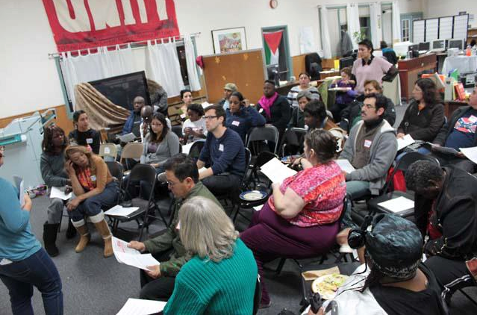

Photo credit: Causa Justa::Just Cause

The Know Your Rights trainings are part of CJJC’s service based strategy and a way to make first contacts. The goals of these trainings are to inform community members of services available to them and policies that might affect them. In addition, these trainings relay and remind us what our rights are as immigrants and humans and how we can defend those rights in case community members are stopped by police or immigration enforcement officers. CJJC not only to help alleviate problems that immigrant communities are facing but also encourage and empower them to seek those changes for their communities.

Goals

Quantitative goals: conduct at least 2 per month in San Francisco and Alameda County.

Qualitative goals:

Inform community members about CJJC and coalitions

Inform community members of their rights

Recruit community members into IRC work

Provide referrals to legal services if needed

Outcome

Through eight Know Your Rights trainings in Oakland and San Francisco schools, my field site partner and I made more than 60 first-contacts, informing them about their rights and providing service referrals.

Planning and Logistics

The target audience for Know Your Rights has been the Latino community as that facilitates language capacity, however, some trainings can be held in conjunction with other coalition member organizations and can be done in different languages.

When finding locations for trainings, much attention has been given to schools: elementary, middle and high schools- to reach an audience of parents. Usually a school is contacted, we will speak to a community or family liaison, or directly with a principal and explain what the trainings are. We will coordinate with them what date and time, classroom location, and possibly having food will look like. Sometimes they will ask for specific information to be included in trainings, which we try to accommodate as much a possible while still reaching our organizational goals for the trainings. Other topics have included: eligibility for social services, housing and tenants rights.

Usually the trainings were conducted with two people who take turns facilitating different sections. Typically the training will be done in 1.5 hours and so planning the time that each section will take is very important.

Follow Up

It is very important to follow up with:

Schools and counselors that were contacted to confirm KYR trainings and thank them for hosting.

Any participants who had particular concerns with immigration cases, who got referred to legal services.

All participants to invite to member meetings, or committee meetings.

Participants who were very interested in IRC, to have one on one meetings with them and gauge their interest, how they want to participate.

Content and Curriculum

(5 minutes) Welcome:

We begin with explaining who CJJC is: a community organization that works with immigrant and African American communities to advance and defend immigrants and tenants rights. We donation based counseling for people going through foreclosure or eviction, or landlord harassment. We do not have any legal attorneys on staff but are able to refer people to other legal services organizations. CJJC is part of different coalitions in Oakland and San Francisco. ACUDIR is a coalition in Alameda County made up of 30 organizations working in defense of immigrants rights. SFILEN is a San Francisco based organization that provides legal and educational services for immigrants. Materials: sign in sheet

(5 minutes) We then go over the agenda and goals. Materials: agenda and goals on butcher paper or dry erase board.

(5 minutes) We will then have an introduction and icebreaker. The purpose of this is so that everyone can feel comfortable sharing with each other. This can be a different activities, if it is a large group we suggest just having people say their name and where they are from in order to save on time.

(10 minutes) Optional Activity:

Immigrant Rights are human rights: (break out into groups)

What are the needs of our community?

what are our basic needs to live?

When we think of our immigrant rights in the US, what comes to mind?

What are our rights as human beings?

Invite members to share what they think

Write it on butcher paper what they share

Add: Need to move, Need to life, Need to work, Need to education, Need to food, Need to be safe-if they don’t bring them up

Offer the following:

We believe the following: All human beings have needs. the needs that you all mentioned: housing etc., not only are our needs but also are our rights. The universal declaration of human rights recognizes this. human rights are connected to our human dignity.

So whatever violations against these are a violation of human rights. We have the right to try to obtain all those rights. Our job is to obtain those rights for our community.

Materials: butcher paper and markers

(10 minutes) Optional Activity:

Group Activity, take some time in 3 groups to share experiences on human rights violations

Ask if someone has an example from personal experience or from what they have heard of a situation if which some of those rights were violated?

Take time to share among the group and then report back.

(15 minutes) Know Your Rights (Materials, KYR handouts)

For now, we believe that the best way to defend our selves is know our rights and to be prepared in case we are ever come into contact with police or ICE.

(see appendix: Know Your Rights document)

(5 minutes) Emergency Plan

(See Appendix KYR materials)

materials: Emergency Plan handouts

(5 minutes) Questions and Answer

(5 minutes) What is being done and how you can act

materials: fliers or invitation to events

(5 minutes) CJJC Business/announcements/closing

Announce that if anyone has a specific issue they can talk to us and we will help to refer them to a trusted organization that has the capacity to help them. Material: referral guides and Form G (see appendix).

End off with something hopeful about the fights we’ve already won (car impoundment etc., local detainer policies) and the work that is still before us.

Assatta Chant or Unity Clap

After making over 160 first-contacts through door-knocking outreach and Know Your Rights trainings, CJJC hoped to reach out and have individual one on one meetings to learn about community members’ vision for a just immigration reform and to recruit them to be a member of CJJC.

In addition to meeting with first contact as a recruitment tool, one-on-one meetings were useful in growing the leadership and development of current members to become active members and member leaders.

The purpose for the one on one meetings that we had were:

to get to know new contacts

to gauge their interest in CJJC and IRC

to gauge their interest in leadership development

learn what skills they can bring

learn what skills they want to gain

Outcome

Over the span of 6 weeks, my field site partner and I had 19 one on one meetings, each around an hour long with CJJC members and first-contacts met through know your rights trainings, community events, and door-knocking.

Planning and Logistics

We called contacts and members who we knew had some interest in IRC.

We let them know why we want to meet with them

Asked if they could meet for half an hour or an hour

Let them know we can meet wherever was best for them:

Their house

A coffeeshop close to them

Their workplace

The CJJC office

We were flexible on days and times

Weekdays/weekends

Mornings/afternoons

Materials

Rap (See Appendix one on ones)

Notebook and pen

Newspaper

Resource guide

Invitation to event

Mission and vision statement

Next Steps

Powerbase: track member participation and leadership development using ranking tools on powerbase

Follow up with members who had specific housing or immigration cases

Follow up with contacts who have not yet had a one on one

Create leadership development plan based on interests
- While making first contacts Know Your Rights trainings and door-knocking, and developing membership and leadership through one on one meetings, we presented several opportunities to become involved in the Immigrant Rights Campaign. We were able to successfully coordinate several meetings including an Immigrant Rights Campaign committee meeting and a monthly member meeting. Some key elements that made these meetings accessible to community members and successful in having a large turn out are:
  - Transportation: some rides are provided when needed from a community member’s home or from a train station to the meeting location. Many community members do not have a personal vehicle and it is difficult for them to come to meeting locations without transportation provided.
  - Food: every meeting held in the evening has a free dinner provided.
  - Translation: every meeting that incorporates English and Spanish speakers has translation provided for those who don’t speak the language being used. This has proven successful in incorporating our Latino and Black community members into discussions and making sure they are able to participate.
  - Childcare: every meeting has free childcare provided. CJJC relies on volunteers to help make sure that parents are not impeded from attending meetings because they are not able to get childcare provided for the meetings.

- IRC committee meeting/trust act celebration, October 25th 2012
- Planning
- We focused our outreach to Spanish speaking Latino members. We planned to make this meeting a committee meeting reintroducing members to current state and local issues and discussing updates of the work ahead as well as a celebration to commemorate the work that members put in to make it possible. The meeting also celebrated other victories since CJJC’s start as an organization to defend and advance immigrants rights.

- Outcome
- Outreach was very effective, we had 21 out of 24 people confirmed come to the meeting. All of them were Spanish speaking members who had been active with CJJC before, either through Housing Rights Campaign, CAFÉ or initial member orientation (Universidad).

- 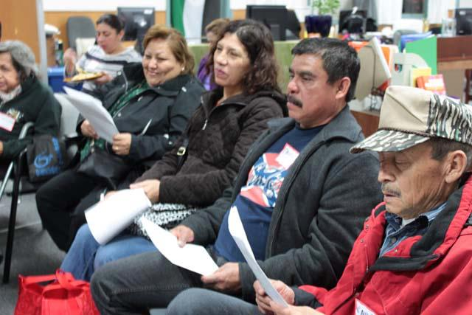
- Active CJJC members at a monthly member meeting. Photo credit: Causa Justa::Just Cause

- IRC themed CAFÉ, January 16th 2013
- Planning
- We planned to do an overview of local, state and national responses to deportation programs. We discussed our involvement politically and our vision for the next few years. We also gave an overview of our rights and recommendations for members in case they came into contact with police or immigration enforcement officers.

- Outcome
- This meeting was a joint-member meeting. So we had many members from Oakland as well as from San Francisco show up. Calling started at least a week ahead of time and we had much help from counselors in Oakland and San Francisco. We had a great transportation coordinator so members from San Francisco were able to commute to Oakland. There was great participation from all the members- Spanish and non-Spanish speaking, Latino and black.

- Causa Justa::Just Cause has been able to use a successful grassroots organizing model to build a base and in turn build the larger immigrant rights movement by building a base through outreach (door-knocking) and education (Know Your Rights trainings).

In order to achieve CJJC’s goal of having the most marginalized and affected groups in leadership, we made those first contacts and then sought to engage their involvement and grow their leadership though one on one meetings and committee meetings. The impact is that immigrant communities are able to know and defend their rights and mobilize in order to grow stronger and begin to advance their rights and fight for improved conditions for themselves and their communities.

- In order to build a larger movement for immigrant rights, a base must first be built. Successful organizing in the face of immediate need: housing issues, immigration cases has been proven possible and effective as evidenced by Causa Justa’s model.

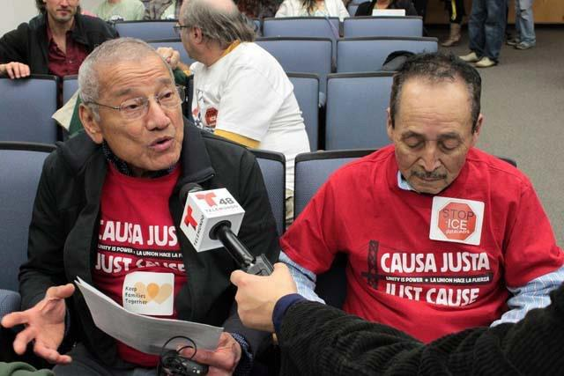
- Member leaders at a public hearing on “Secure Communities”. Photo credit: Causa Justa::Just Cause

Promotional flier for Know Your Rights trainings

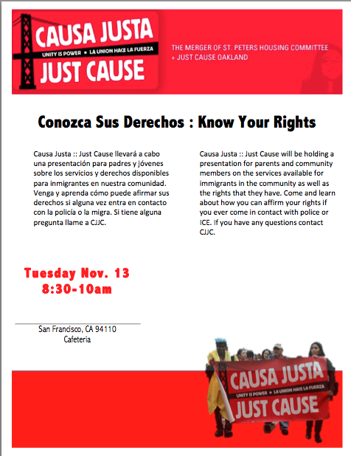

Interview Script used for One-on-one meetings

Hello, thank you very much for your time and for meeting with me.

How are you doing?

We think it is important to meet with you as an organization that is based on membership from the community. We are nobody without your participation and leadership. More than anything, we wanted to learn about your interest in our campaign and know how we can help you become more involved as well as present opportunities for leadership development.

For this meeting: I would like to share a little more about the Immigrant Rights Campaign, how you can become involved, and how we can create opportunities for leadership growth and development if there are skills you would like to strengthen.

1) Follow up if they were not able to attend a meeting they said they would go to: You expressed interest in receiving more information on KYR but were not able to go to the training that we had last Thursday. Is there something we can improve next time so you can come to the next training or event?

2) October 25, we had a IRC meeting. We shared CJJC victories over the last two years and our goals moving forward. Members also shared their vision for a campaign: what we want to see in our community. What is YOUR vision for the IRC work in your community?

3) Do you think you can become involved with the IRC? What are some possible barriers that you think there would be that make things difficult for you to participate?

4) How would you like to participate? Are there some talents or capabilities that you would like to use in our IRC campaign? (i.e. making calls, attend coalition meeting, recruitment, facilitate KYR training).

5) What are some abilities you want to grow during the IRC work? (i.e. facilitate meeting, public speaking, and communications, learn about political process, and phone banking).

6) Anything else you would like to share or any questions?

7) Here is our Mission and Vision statement that you can read in your time.

8) Pitch for IRC meeting January 24, 5:30-7:30pm W. Oakland Office.

Can you come? Do you need a ride? Childcare?

- CJJC is part of coalitions in the Bay Area in Alameda County and San Francisco that include coalitions focused on advancing the rights of immigrants, workers, tenants and homeowners. The following is a summary, descriptions of coalitions that CJJC is a part of and lists of all the organizations that are in partnership with CJJC through those coalitions.

- Local:
  - Alameda County United in Defense of Immigrant Rights
  - San Francisco Immigrant Legal And Education Network
  - San Francisco Immigrant Rights Defense Committee
  - Oakland Rising
  - San Francisco Rising

- Statewide:
  - California Immigrant Policy Center

- National:
  - UNITY coalition
  - National Day Labor Organizing Network
  - National Network for Immigrant and Refuge Rights
  - Right to the City
  - Grassroots Global Justice

- Local:
- SFILEN (San Francisco Immigrant Legal and Education Network), founded in 2007 it is a coalition of 13 legal and outreach organizations that provide legal and educational services to the immigrant community in San Francisco. SFILEN has been able to function on local government grants over the last few years and so monthly and annual reporting is very important in being able to meet its goals and continue to receive funds from the city. Tracking, recording and reporting events, participation, and feedback from the community is very important.

- general work and responsibilities
  - meet goals
    - 5 referrals per month
    - at least 2 KYR trainings per month
    - track all event participation (sign in sheets, fliers, photos, quotes, etc.).
- outreach work and responsibilities
  - Conduct Know Your Rights trainings, letting people know about SFILEN and services available to them
  - Refer immigrants that need legal services to legal organizations within the network by filling out a form-G (see SFILEN resource guide and Form G, appendix)
  - Help plan, coordinate, and advertise and turnout community members to educational events and forums
    - DACA (Deferred Action) forums
    - Citizenship forums
    - Know Your Rights trainings
  - SF Immigrant Integration Project
  - International Migrants Day Celebration

- ACUDIR (Alameda County United in Defense of Immigrants’ Rights)
  - Made up of about 30 immigrant serving community based organizations in Alameda County
  - Documentation project: story collecting, documentation of human rights abuses

